Planning and Environment Act 1987

QUEENSCLIFFE PLANNING SCHEME
AMENDMENT C40quen

EXPLANATORY REPORT

Overview
The amendment proposes to incorporate recommendations of the Heritage Review of Places in Fisherman’s Flat Urban Conservation Precinct (HO1), Fisherman’s Flat, Queenscliff, Victoria (Ecology and Heritage Partners, August 2023).
The proposed changes to the Queenscliffe Planning Scheme are as follows:
- Amend the Fisherman’s Flat Urban Conservation Precinct Heritage Design Guidelines 2021 located in the Schedules to Clause 43.01 Heritage Overlay and Clause 72.04 Incorporated documents.
- Introduce a Statement of Significance for Fisherman’s Flat Urban Conservation Precinct in the Schedules to Clause 43.01 Heritage Overlay and Clause 72.04 Incorporated documents.
- Include the Heritage Review of Places in Fisherman’s Flat Urban Conservation Precinct (HO1), Fisherman’s Flat, Queenscliff, Victoria (Ecology and Heritage Partners, 4 August 2023) as a Background Document in the Schedule to Clause 72.08 Background documents.

Where you may inspect this amendment
The amendment can be inspected free of charge at the Borough of Queenscliffe website at www.queenscliffe.vic.gov.au.
The amendment is also available for public inspection, free of charge, during office hours at the following place:

The Borough of Queenscliffe
50 Learmonth Street
QUEENSCLIFF VIC 3225
The amendment can also be inspected free of charge at the Department of Transport and Planning website at http://www.planning.vic.gov.au/public-inspection or by contacting the office on 1800 789 386 to arrange a time to view the amendment documentation.

Submissions
Any person may make a submission to the planning authority about the amendment. Submissions about the amendment must be received by 12 April 2024.
A submission must be sent to:

Tim Crawford
Manager Community and Regulatory Services
Borough of Queenscliffe
50 Learmonth Street (PO Box 93)
QUEENSCLIFF VIC 3225

Panel hearing dates
In accordance with clause 4(2) of Ministerial Direction No.15 the following panel hearing dates have been set for this amendment:
- directions hearing: 3 June 2024

- panel hearing: 1 July 2024

Details of the amendment

Who is the planning authority?

This amendment has been prepared by the Borough of Queenscliffe which is the planning authority for this amendment.
The amendment has been made at the request of the Borough of Queenscliffe.

Land affected by the amendment

The amendment applies to Fisherman’s Flat in the township of Queenscliff. The geographic area of Fisherman’s Flat is defined in the Queenscliffe Planning Scheme by the application of Heritage Overlay 1 (HO1). See extract from Fisherman’s Flat Urban Conservation Precinct Heritage Design Guidelines 2021 below.

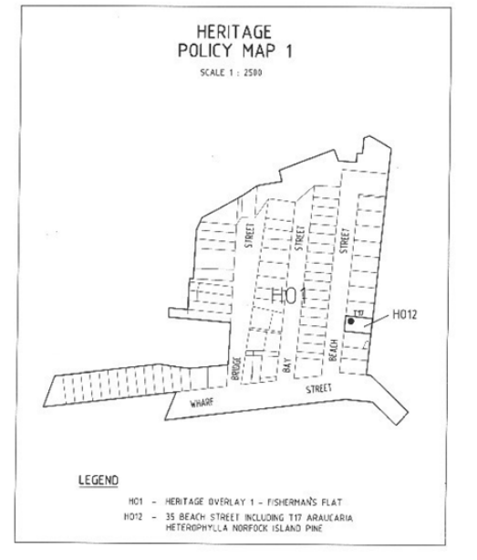

Fisherman’s Flat is an area located in the north-east corner of the township of Queenscliff, approximately 105 kilometres south-west of the Melbourne CBD. The precinct is bordered to the north by Swan Bay, to the east by the Queenscliffe Maritime Museum and Queenscliff Harbour, to the west by the Queenscliff Boat Ramp and associated carpark and to the south by parklands and the northern end of Hesse Street.

Fisherman’s Flat contains 74 individual land parcels. An east-west section of Wharf Street forms the southern road boundary of the precinct. Larkin Parade, which runs east west between Bridge Street and Harbour Street, forms the northern road boundary. Bridge Street, Bay Street, Beach Street and Harbour Street all run north south and connect Wharf Street and Larkin Parade. The entire precinct, including land parcels and road reserve, covers an area of approximately 6 hectares.

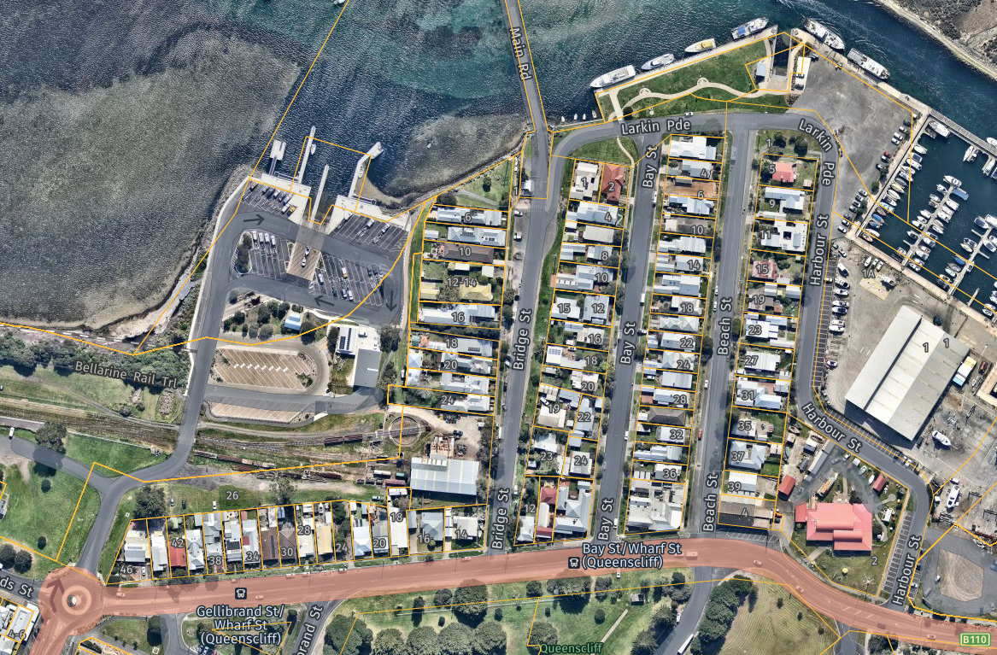
Queenscliff Harbour
Queenscliff Boat Ramp
Swan Bay

There is one individual heritage listing located within the HO1 precinct. The listing has the designation HO12 and applies to a Norfolk Island Pine growing within the property boundary of 35 Beach Street.

What the amendment does

The amendment introduces a Statement of Significance for Fisherman’s Flat and proposes changes to the Fisherman’s Flat Urban Conservation Precinct Heritage Design Guidelines (Borough of Queenscliffe, 2021). The amendment also seeks to introduce the Heritage Review of Places in Fisherman’s Flat Urban Conservation Precinct (HO1), Fisherman’s Flat, Queenscliff, Victoria (Ecology and Heritage Partners, August 2023) as a background document in the Queenscliffe Planning Scheme.
Specifically, the amendment makes the following changes:
- Amends the Schedule to Clause 43.01 (Heritage Overlay) and the Schedule to Clause 72.04 (Incorporated Documents) to:
  - Insert the Fisherman’s Flat Urban Conservation Precinct Statement of Significance (Ecology and Heritage Partners, August 2023) incorporated document.
  - Replace the Fisherman’s Flat Urban Conservation Precinct Heritage Design Guidelines (Borough of Queenscliffe, 2021) incorporated document with Fisherman’s Flat Urban Conservation Precinct Heritage Design Guidelines (Borough of Queenscliffe, 2023).
- Amends the Schedule to Clause 72.08 (Background Documents) to insert the following background document:
  - Heritage Review of Places in Fisherman’s Flat Urban Conservation Precinct (HO1), Fisherman’s Flat, Queenscliff, Victoria (Ecology and Heritage Partners, 4 August 2023).

Strategic assessment of the amendment

Why is the amendment required?

The township of Queenscliff contains diverse residential, commercial and military building stock that maps its early development as a fishing port, government and resort town. The heritage value attributed to Queenscliff is reflected in the planning scheme through the application of the Heritage Overlay over much of the township.

The fishing industry in Queenscliff commenced in the 1850’s with fishermen camping on the beach between Swan Island and Queenscliff township. In 1864 a number of Crown land allotments were leased to fishermen on which they constructed modest homes for themselves and their families. It is these allotments that collectively became known as Fisherman’s Flat.

It is Queenscliff’s early history as a fishing village that the amendment addresses through the strengthening of existing heritage protection applicable to Fisherman’s Flat.

Fisherman’s Flat is currently protected by a Heritage Overlay (HO1) which triggers a planning permit requirement for development that alters the appearance of a building (including painting) and fencing.

Applications for planning permits are currently assessed against the Municipal Planning Strategy, the Planning Policy Framework and the Fisherman’s Flat Urban Conservation Precinct Heritage Design Guidelines (Borough of Queenscliffe, 2021). Recent development proposals within Fisherman’s Flat have highlighted shortcomings in the current assessment regime. These include a lack of detailed assessment of heritage buildings located to the rear of existing dwellings and deficiencies in the definition of Contributory and Non-Contributory buildings. There is an emerging risk that the current provisions protecting built form and character in Fisherman’s Flat are not sufficient to prevent development that may erode the acknowledged heritage values in the precinct.
How does the amendment implement the objectives of planning in Victoria?
The amendment implements the following objectives of planning in Victoria.
(c) to secure a pleasant, efficient and safe working, living and recreational environment for all Victorians and visitors to Victoria; and
(d) to conserve and enhance those buildings, areas or other places which are of scientific, aesthetic, architectural or historical interest, or otherwise of special cultural value; and
How does the amendment address any environmental, social and economic effects?
The amendment proposes to amend existing provisions, and introduce a Statement of Significance, with the aim of strengthening and clarifying understanding of the heritage values of Fisherman’s Flat.
The cumulative impact of the amendment will not result in additional environmental, social or economic effects.
Does the amendment address relevant bushfire risk?
Fisherman’s Flat is not identified as an area that is subject to risk of bushfire.

Does the amendment comply with the requirements of any Minister’s Direction applicable to the amendment?
The amendment complies with Ministerial Direction s7(5) – The form and content of planning schemes. The amended provisions have been drafted in accordance with this direction.
The amendment complies with Ministerial Direction 11 – Strategic assessment of amendments. Consideration and response to each of the relevant strategic considerations in Ministerial Direction 11 is provided in this Explanatory Report.
The amendment complies with Ministerial Direction 15 – The planning scheme amendment process.
How does the amendment support or implement the Planning Policy Framework and any adopted State policy?

The amendment supports and implements the following provisions in the Planning Policy Framework:

Clause 15.01-1S Built environment
The amendment addresses Clause 15.01-1S through the provision of additional guidance on building design that respects the established character and heritage values of Fisherman’s Flat.

Clause 15.01-5S Neighbourhood character
The amendment supports the protection of the established neighbourhood character, cultural heritage and sense of place of Fisherman’s Flat. It does this by recognising and protecting the built form and subdivision pattern that has remained relatively untouched since the first Crown land allotments were leased to fishermen in the 1860’s.

Clause 15.01-5L-01 Neighbourhood character in the Borough
The introduction of a Statement of Significance for Fisherman’s Flat and strengthened design guidelines will assist in the preservation of the established character of the precinct.

Clause 15.01-5L-02 Neighbourhood character in Queenscliffe urban heritage areas
Clause 15.01-5L-02 identifies building siting, design and fencing strategies for land identified in the planning scheme as urban heritage and contributory areas. Further detail, built upon these strategies and specific to Fisherman’s Flat, is proposed in revised design guidelines.

Clause 15.03-1S Heritage conservation
Clause 15.03-1S seeks to ensure that places of heritage significance are conserved through the retention of contributory elements, encouragement of development that is respectful of identified heritage values and conservation and enhancement of aesthetic, architectural, cultural and social significance. The revised provisions proposed as part of this amendment are a direct response to the identified need to conserve the heritage places identified in Fisherman’s Flat.

How does the amendment support or implement the Municipal Planning Strategy?
The amendment supports and implements the following provisions of the Municipal Planning Strategy:
Clause 02.02 Vision for the municipality talks specifically to the unique heritage in the Borough. This amendment aims to assist in preserving our unique heritage by strengthening protection for Fisherman’s Flat.
Clause 02.03-4 Built environment and heritage nominates the protection of the distinctive heritage character of the Borough as a strategic direction of Council.
Does the amendment make proper use of the Victoria Planning Provisions?
The Heritage Overlay is currently utilised as the most appropriate Victoria Planning Provision to identify and protect the values of Fisherman’s Flat. The amendment does not propose modification to the existing listing for Fisherman’s Flat in the Schedule to the Heritage Overlay.
The amendment proposes the introduction of a Statement of Significance for Fisherman’s Flat at Clause 72.04 of the Queenscliffe Planning Scheme. The Statement of Significance will provide additional background information on what, why and how Fisherman’s Flat is significant. The Statement of Significance has been drafted in accordance with PPN01 – Applying the Heritage Overlay and in accordance with Ministerial Direction on the form and content of planning schemes.
How does the amendment address the views of any relevant agency?
The views of agencies were not sought in the development of the amendment.
Does the amendment address relevant requirements of the Transport Integration Act 2010?
The proposed amendment will not result in an impact on the transport system. Therefore, no assessment against the requirements of the Transport Integration Act 2010 is required.
Resource and administrative costs

What impact will the new planning provisions have on the resource and administrative costs of the responsible authority?

There will be no additional resource or administrative costs attributable to Council because of the amendment.

ATTACHMENT X - Mapping reference table
Location | Land /Area Affected | Mapping Reference | Address | Proposed changes
 |  |  |  | Zone | Overlay | Deletion
[Insert Town, Precinct and etc] | [Insert land or area affected] | [Insert map reference] | [insert address] | [insert zone change if applicable] | [insert overlay change if applicable] | [insert deletion change if applicable]
Example  Gumnut | Land bounded by Gumnut Road and Cupid Lane, Gumnut | Gumnut C001 001vpoMap37 Exhibition  Gumnut C001 002vpoMap38 Exhibition | 1-11 Gumnut Road, Gumnut | Rezone from C1Z to MUZ1 | DDO58 | D-DDO1

