Fisherman’s Flat Urban Conservation Precinct Heritage Design Guidelines

Borough of Queenscliffe, 2023
Heritage Place:
Fisherman’s Flat Urban Conservation Precinct
PS ref no:
HO1 and HO12

Conservation
- Protect and enhance the visual and historical character of the precinct through the retention of fisherman’s dwellings and outbuildings and ensure that the fishing village characteristics of the area set it apart from the main town centre.
- Retain the modest architectural characteristics, and general uniformity in mass and scale and overall visual consistency of the buildings featuring a similar form, style and setback along the street frontages.
- Retain the historic integrity of the area in any replanting program.
- Retain the locally unique subdivision pattern, with dual access to many properties by discouraging further subdivision of land, except to realign boundary between lots.

Building siting, design and form
- Encourage the use of the traditional building design of the precinct, including narrow eaves, gable roofs, verandahs, vertical rectangular windows and unbroken facades.
- Site and design buildings and works to blend with the prevailing character of the precinct and to not detract from the environmental and landscape values of Swan Bay and the coastline by:
  - Providing a front setback that matches the setbacks of adjacent buildings, or if these are different, a setback that is between the setbacks of adjacent buildings.
  - Designing dwelling facades to not be greater than 10 metres in width.
  - Discouraging buildings to exceed one storey or 6 metres above natural ground level, and restrict existing buildings above these heights from increasing further in height.
  - Discouraging the alteration of building height of any surviving secondary cottages/sleepouts (outbuildings)
  - Ensuring the highest point of the roof of a building is not greater than the highest adjacent building.

Materials, colours and finishes
- Encourage the use of the traditional building materials of the precinct, including in any in-fill development, including:
  - Corrugated iron pitched roofs.
  - Vertical rectangular timber-framed windows.
  - Horizontal timber weatherboard walls.
  - Brick chimneys.
  - Timber verandahs.

Fences
- Maintain the traditional fencing of the precinct, such as low pickets or twisted wire for front fences and capped corrugated iron for rear or adjacent to vacant land fences.
- Encourage the use of traditional materials and construction techniques for new fences.
- Design fences to not exceed:
  - 1200 mm for the frontage.
  - 2000 mm for side, rear or adjacent to vacant land.

Outbuildings
- Discourage the alteration of any outbuildings which were constructed by fishermen or their families during the respective leasehold period of the property, unless for essential maintenance works or works that enhance the historical value of the building.
- Discourage the demolition of any outbuildings which were constructed by fishermen and their families during the respective leasehold period of the property.

Demolition
- Allow the demolition of a Non-contributory building or element or outbuilding not constructed by a fisherman or their families during the respective leasehold period of the property to be permitted.
- Discourage the full demolition of Contributory buildings or elements that will adversely affect the historical, aesthetic and social significance of the precinct.
- Only allow the demolition of a Contributory building or element if it involves the removal of later alterations, additions and works if the removal enhances the significance of the heritage place and contributes to the long-term conservation of the significant fabric of the citation or element.

Primary sources
- Geelong Region Historic Buildings and Objects Study (Allan Willingham for the Geelong Regional Commission, 1986)
- Queenscliffe Urban Conservation Study (Allom, Lovell and Associates Pty Ltd, 1984)
- Heritage Review of places in Fisherman’s Flat Urban Conservation Precinct (HO1), Fisherman’s Flat, Queenscliff, Victoria (Ecology and Heritage Partners, 4 August 2023)

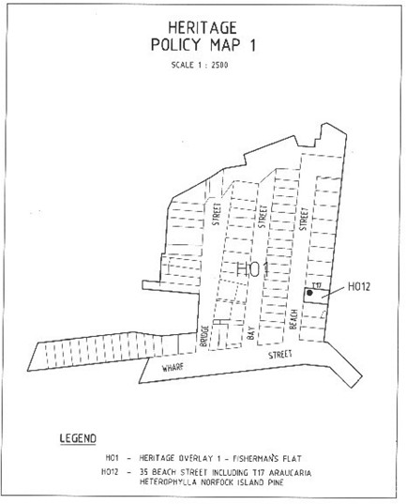
Heritage policy map

