Borough of Queenscliffe Planning Scheme

Fisherman’s Flat Urban Conservation Precinct Statement of Significance
Borough of Queenscliffe, 2023

Heritage Place: | Fisherman’s Flat Urban Conservation Precinct | PS ref no: | HO1, HO12

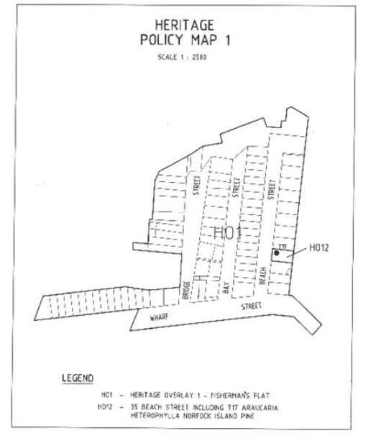

What is significant?
The Fisherman’s Flat precinct is significant for its low-scale and residential building stock, comprising modest fishermen’s residences ranging in date from the 1860’s and 1870’s through to the c.1940’s, as well as for its relatively intact subdivision pattern. While no individual building is significant, many intact contributory buildings with the precinct are identified in the individual citations.
Contributory buildings:
Bay Street: 8, 10, 16, 20, 22, 24
Beach Street: 2, 4, 5, 6, 8, 9, 11, 12, 14, 15, 18, 19, 20, 22, 23, 24, 26, 27, 31, 32, 35, 36, 37
Bridge Street: 6, 8, 16, 18, 19, 20, 22, 23, 24
Wharf Street: 4, 6, 12, 14, 20, 22, 26, 28, 36, 38, 40, 44, 46

Features that do not contribute to the significance of this precinct include non-original alterations and additions to the contributory buildings nominated above and the houses at 2 Bay Street, 18 Bay Street, 10 Beach Street, 16 Beach Street, 30 Beach Street, 1 Bridge Street, 10 Bridge Street, 12-14 Bridge Street, 18 Wharf Street, 30 Wharf Street, 32 Wharf Street and 42 Wharf Street.
How is it significant?
The Fisherman’s Flat precinct is of local, historic, aesthetic and social significance to the Borough of Queenscliffe.
The precinct is characterised by its original subdivision pattern which allowed for double-fronted properties and its modest dwellings built between the 1860’s and the 1940’s.

Why is it significant?
Historically, the precinct is representative of an integral part of Queenscliffe’s history, demonstrated by the modest nature of the dwellings.

The Fisherman’s Flat precinct is historically important as a defined area of the Queenscliff township specifically reserved by the Crown in the 1850’s for development as fishermen’s residences. Until the 1950’s, the allotments were all leased from the Crown Lands Department. The largely intact subdivision layout dates to 1856. Its wide streets and dual frontage arrangements are distinct from the more traditional layout of the broader township and demonstrate the physical and social differences that existed between the fishing community and other residents and visitors to Queenscliff in the nineteenth century. Despite modifications, many of the fishermen’s residences are still broadly intact externally and though modest in their form and fabric, provide a valuable insight into the lives of a community of great importance in the history of the township of Queenscliff and the Borough as a whole.

The Fisherman’s Flat precinct is of significance for its strong historical association with the fishing community in Queenscliff. While the buildings themselves are simple and modest with few architectural pretensions, the precinct as a whole has a particular visual quality that derives from its wide streets, unusual subdivision pattern and the consistency of scale, form and siting of its building stock. Individual buildings retain a strong sense of cohesion from the consistency of massing and detailing within the precinct.

Primary source
Heritage Review of Places in Fisherman’s Flat Urban Conservation Precinct (HO1), Fisherman’s Flat, Queenscliff, Victoria, (Ecology & Heritage Partners, 4 August 2023)

This document is an incorporated document in the Queenscliffe Planning Scheme pursuant to section 6(2)(j) of the Planning and Environment Act 1987

